CKMLCP -

Functionality
In this transaction you can perform single level and multi level actual costing by plant. This allocates the follow-up costs to the semifinished and finished products, and the differences against a material’s preliminary valuation price (‘S’ standard) to the material's inventory and consumption.
The actual cost component split is used to analyze actual costs over multiple production levels.
- Differences from preliminary valuation
- Price differences
- Exchange rate differences
This is accomplished with the functions of single-level and multilevel price determination. The recalculated prices can then be used for future valuation.

Scenario
This system task is a part of a month-end closing procedure. It performs actual material costing run.

Requirements
The material ledger is active.
The price determination indicator in the material master is set to ‘3’.
The price control indicator in the material master is set to ‘S’.

Menu Path | Accounting → Controlling → Product Cost Controlling → Actual Costing/Material Ledger → Actual Costing → CKMLCP - Edit Costing Run
Transaction Code | CKMLCP

1. Double Click on CKMLCP - Edit Costing Run

Costing Cockpit: Actual Costing - Change / Execute

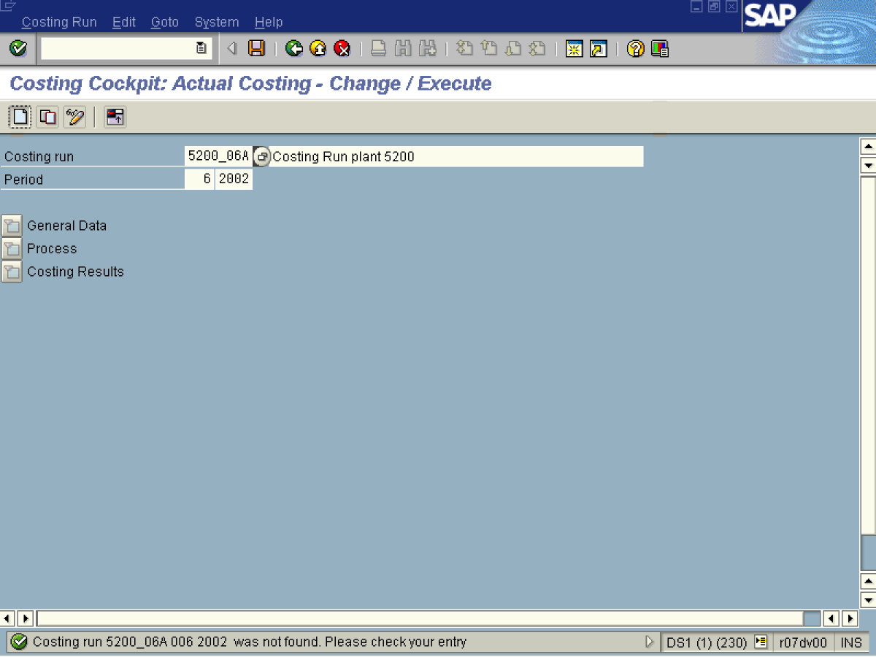
2. Update the following fields:

Field Name | Field Description | Values
Costing run | Number of the Costing run. This number should start with Plant_PeriodLetter (for following runs in the same period for the same plant) i.e. 5200_06A. Please refer to naming conventions. | Example: 5200_06A
Costing run | Description of the Costing run should include information about the plant. | Example: Costing Run plant 5200
Period | Number identifying a fiscal month | Example: 06
Period | Number identifying a fiscal month | Example: 2002
3. Click the Enter button.
4. Click Create .

Create Costing Run

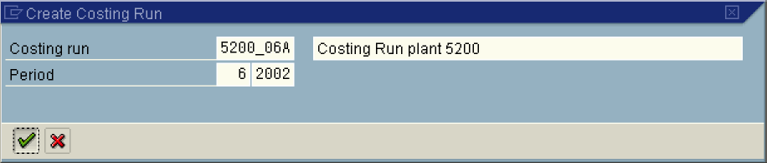
5. Click the Enter button.
Costing Cockpit: Actual Costing - Change / Execute

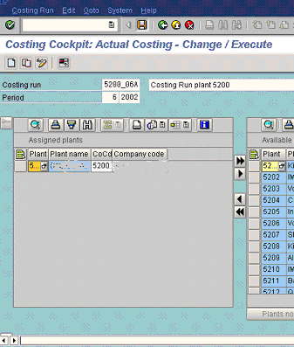
6. Click 5200 .
7. Click Column left Button .
8. Click the Save button.
Note: It is advisable to prepare separate costing runs for each plant due to the naming convention and performance of the system..
9. Select GotoSwitch Screen Formatting.
10. Click <tab button> Process .
Costing Cockpit: Actual Costing - Change / Execute

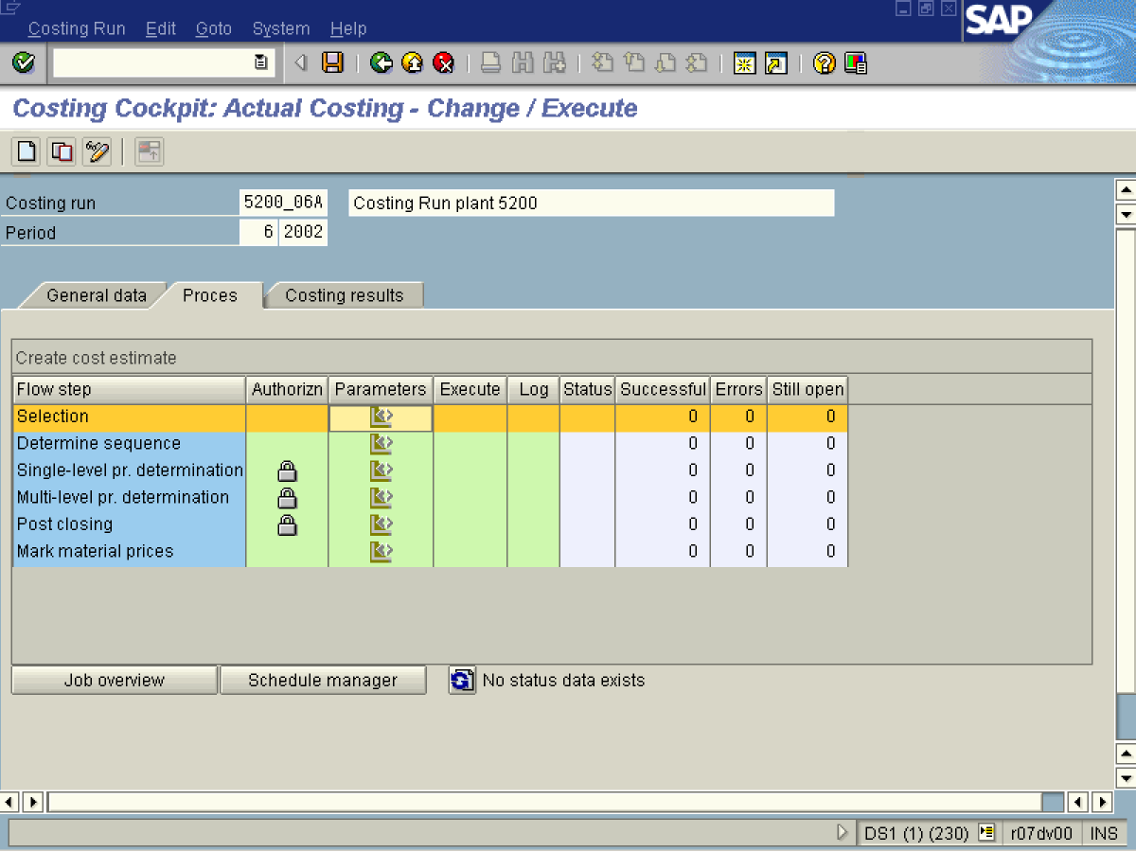

11. Click Button.

Maintain Variant: Report SAPRCKMLMV_RUN_BASIC_LIST, Variant 0000000000

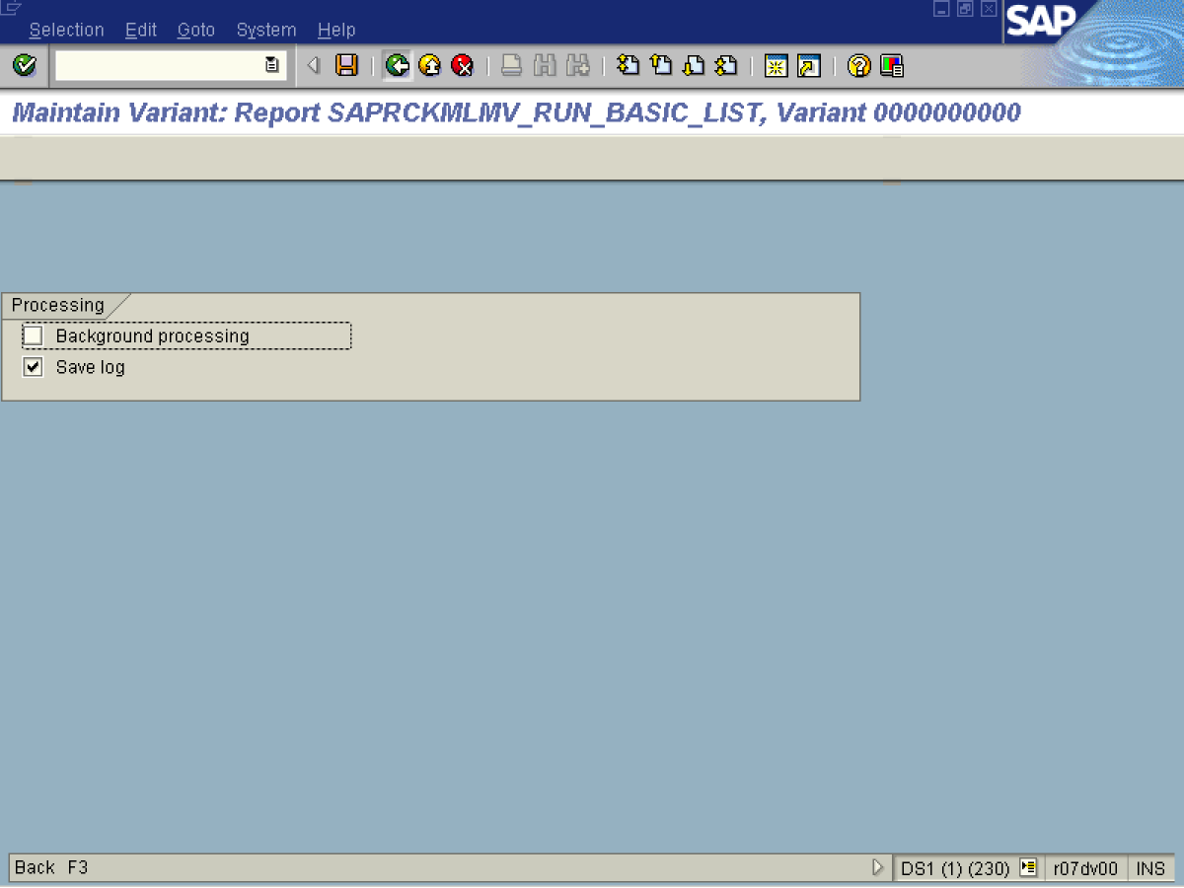

12. Click Background processing .
13. Click Back .

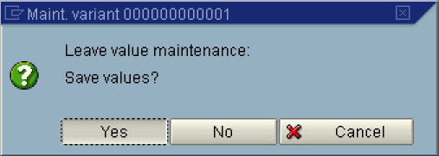
14. Click the Yes Button.
Costing Cockpit: Actual Costing - Change / Execute

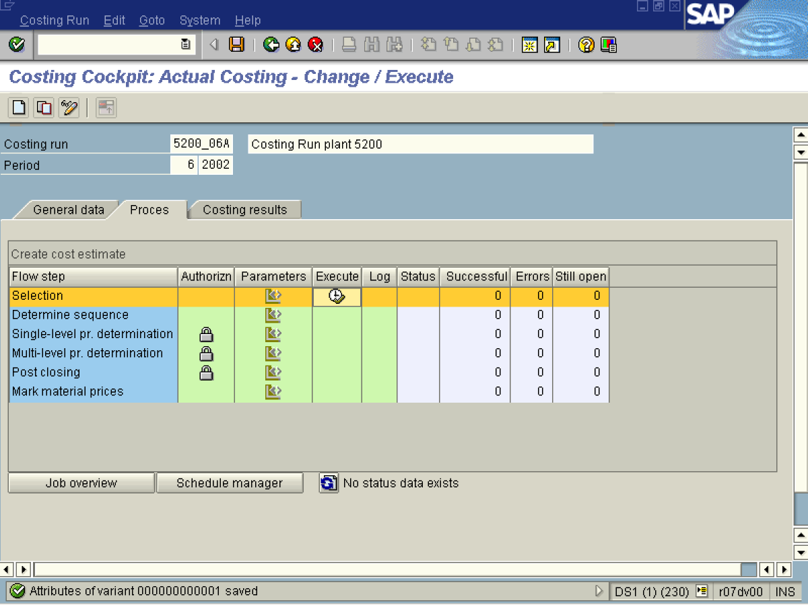
15. Click the Execute Button .

Actual Costing: Select Materials

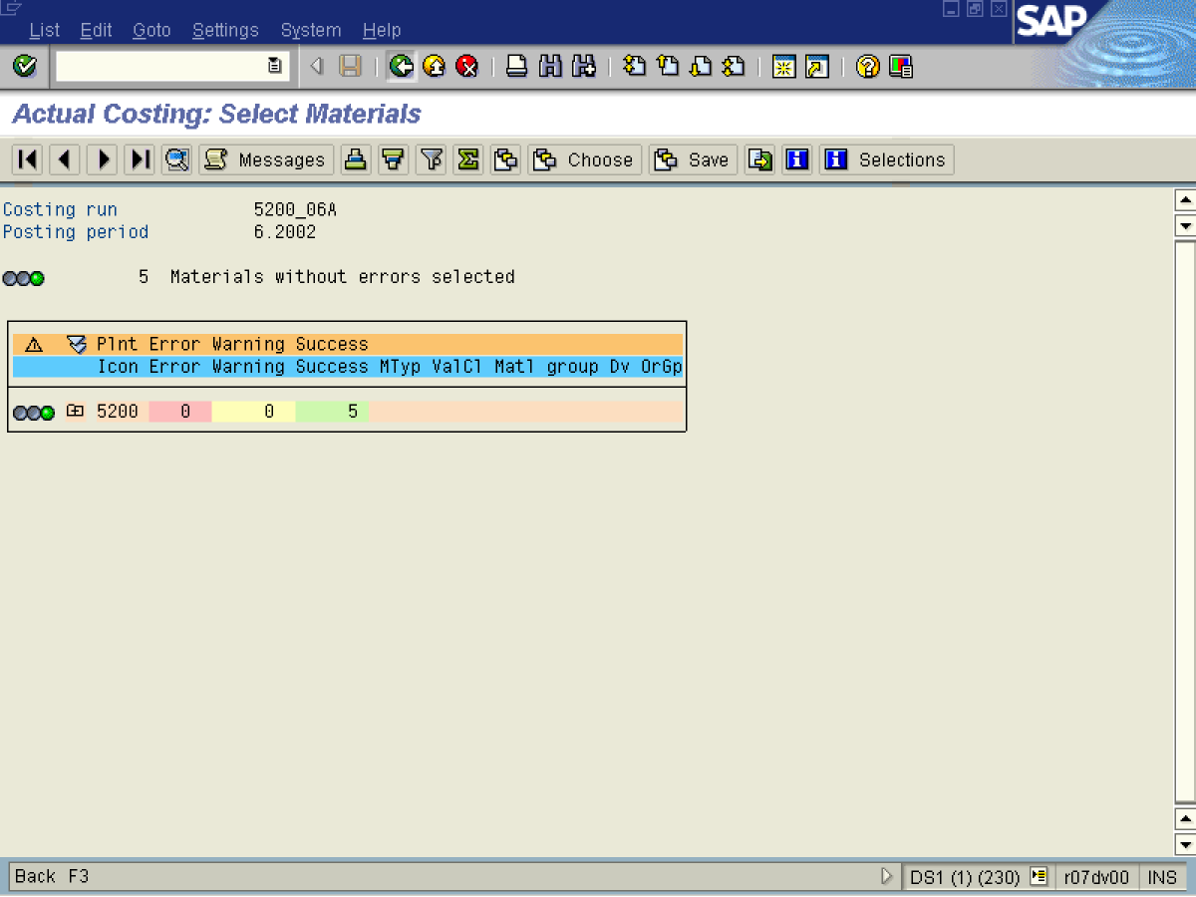
16. Click Back .

Costing Cockpit: Actual Costing - Change / Execute

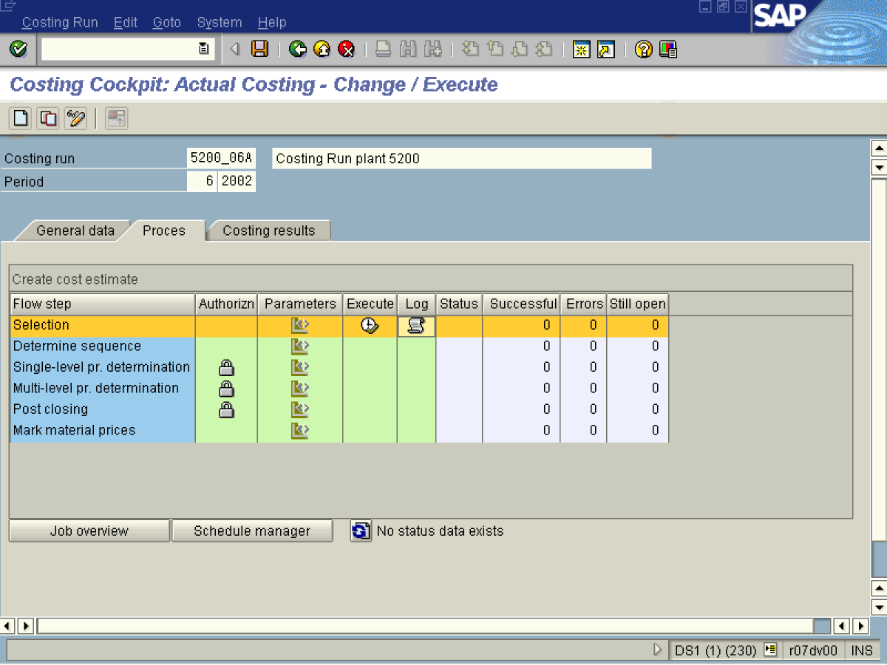

17. Click Button .

Choose Log

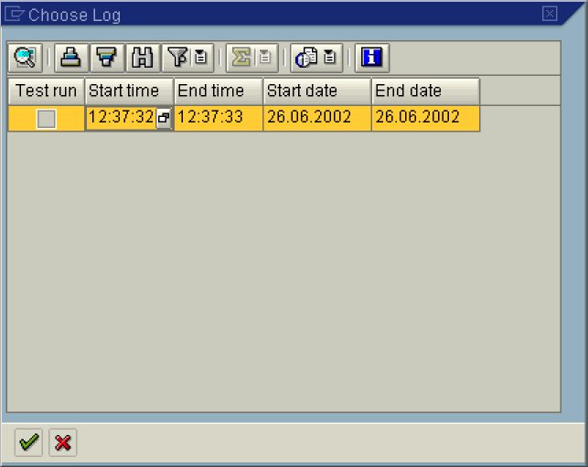

18. Press the Display button.

Choose Log

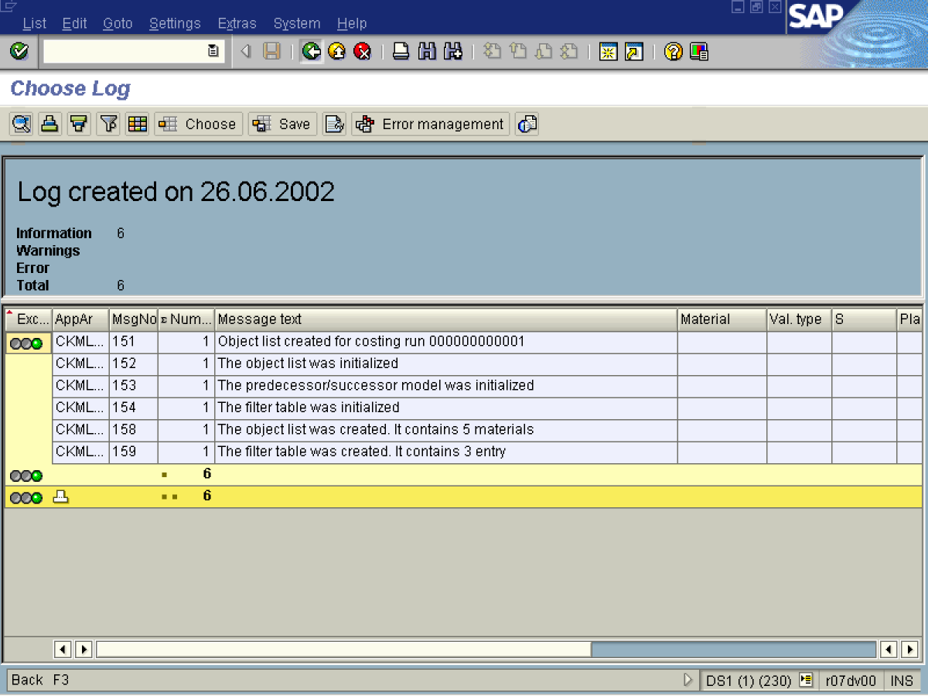

19. Click Button .

20. Click Back .

Choose Log

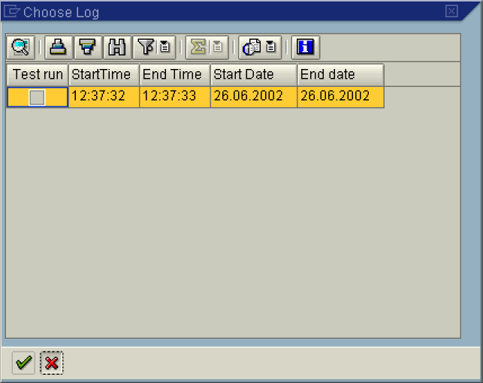

21. Click Cancel button.

Costing Cockpit: Actual Costing - Change / Execute

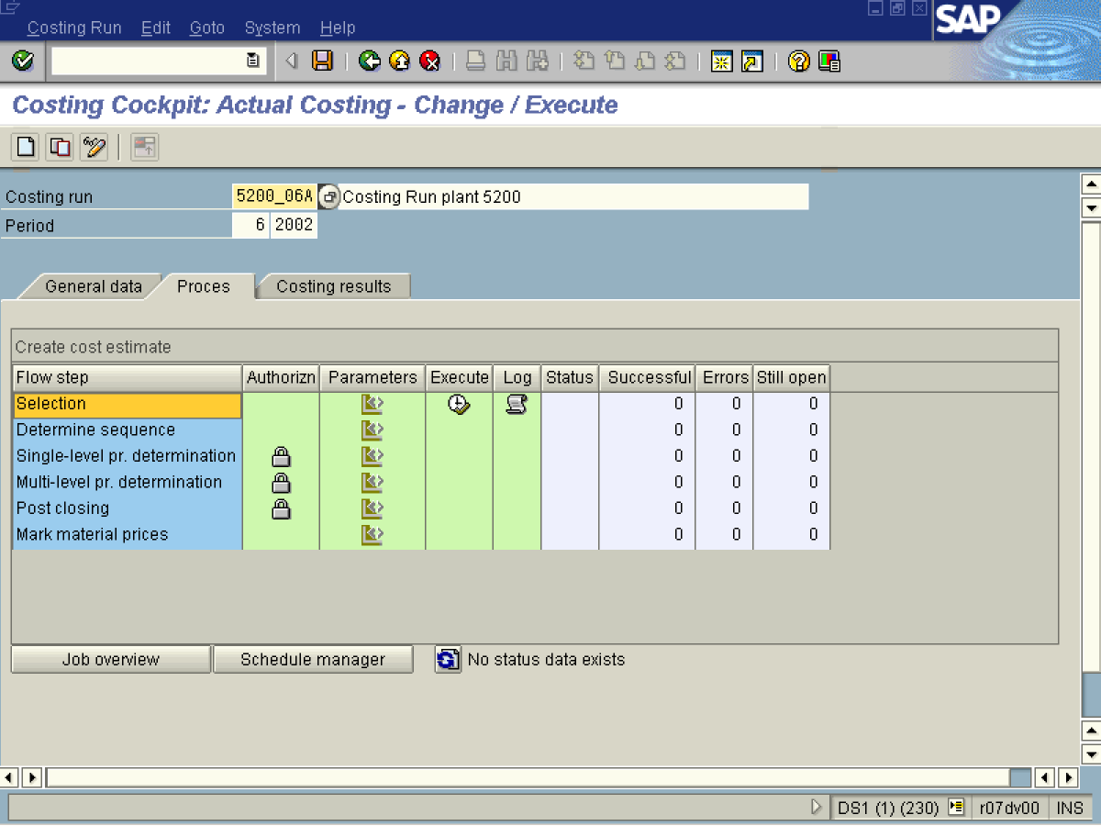

22. Click <tab button> Costing results .

Costing Cockpit: Actual Costing - Change / Execute

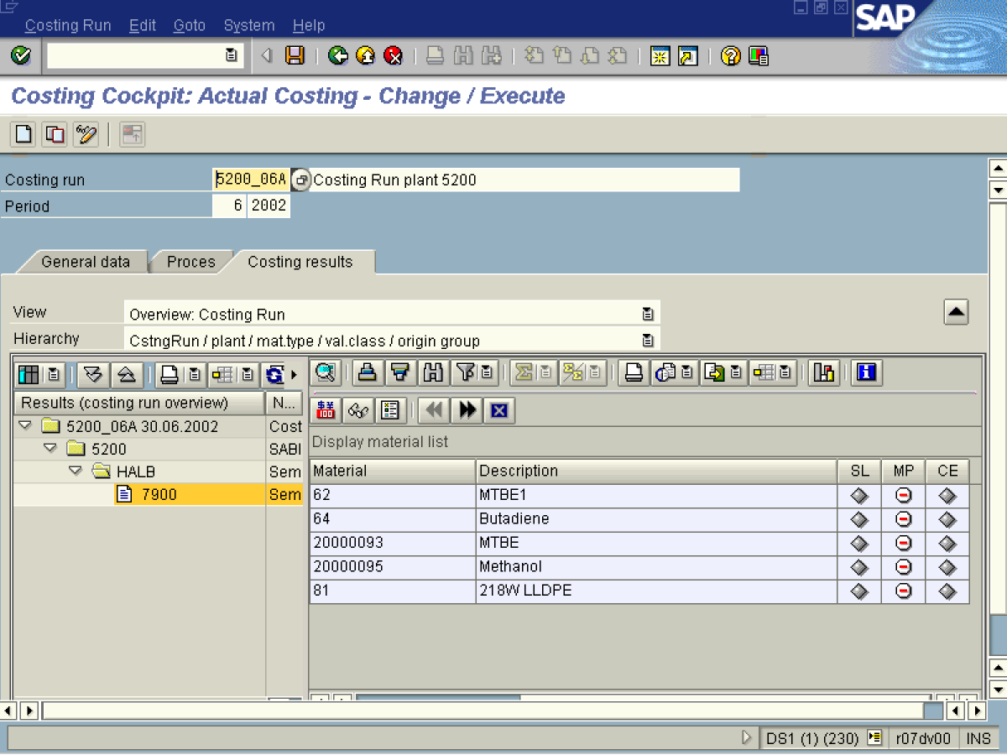

 No material for multi-level price determination was chosen.

23. Select tree view node 5200.

24. Select tree view node 7900.

25. Click <tab button> Process .
Costing Cockpit: Actual Costing - Change / Execute

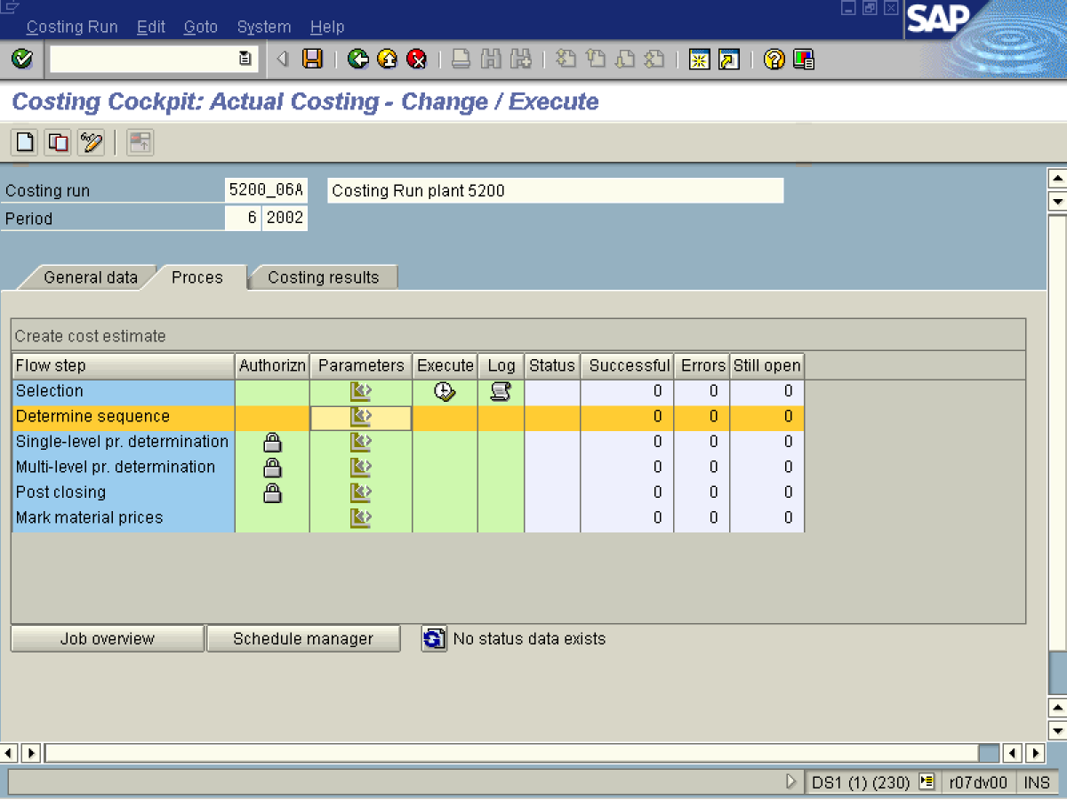

26. Click Button.

Maintain Variant: Report SAPRCKMLMV_RUN_CREATE_STEPS, Variant 00000000

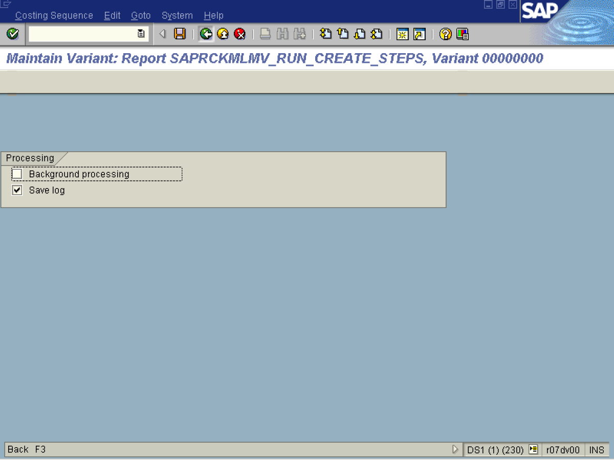
27. Click Background processing .
28. Click Back .

29. Click the Yes Button.

7Costing Cockpit: Actual Costing - Change / Execute

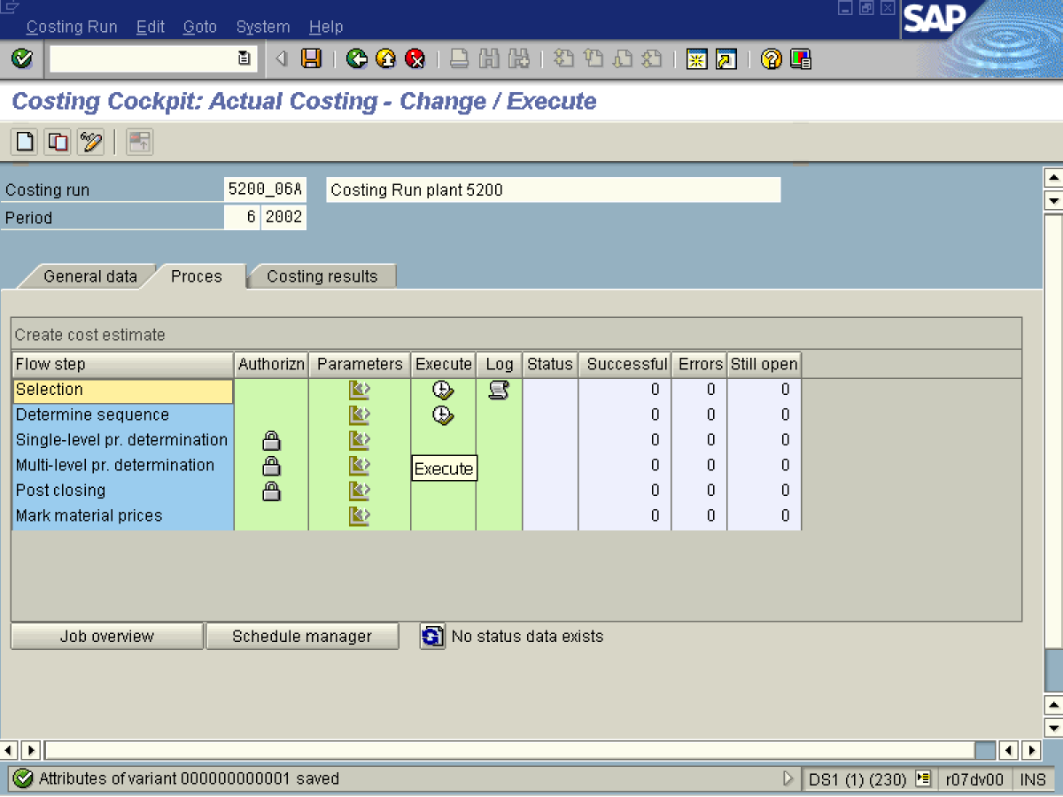

Actual Costing: Determine Costing Sequence

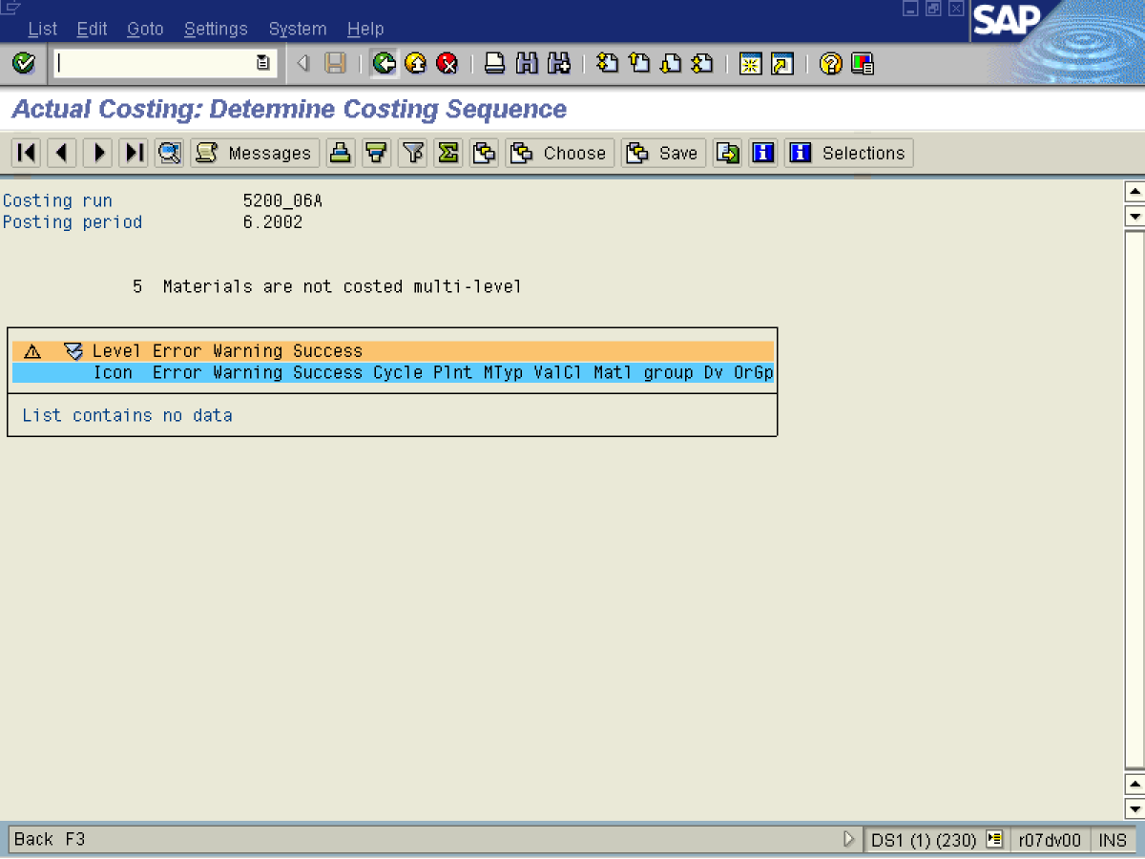

30. Click Back .

Costing Cockpit: Actual Costing - Change / Execute

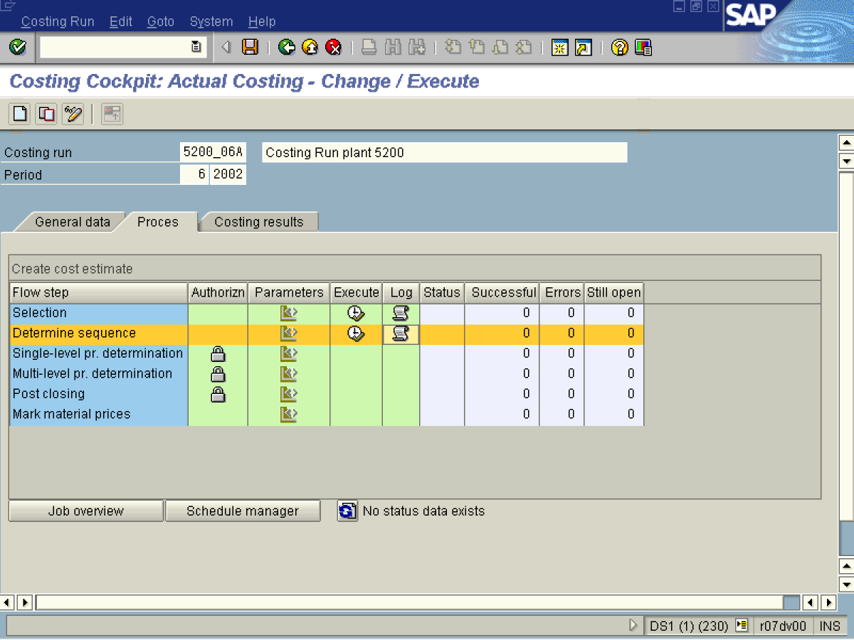
31. Click Button 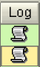.

Choose Log

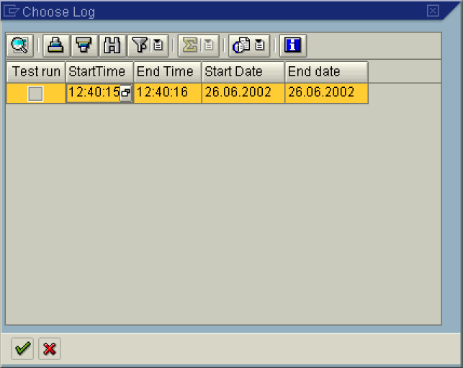

Choose Log

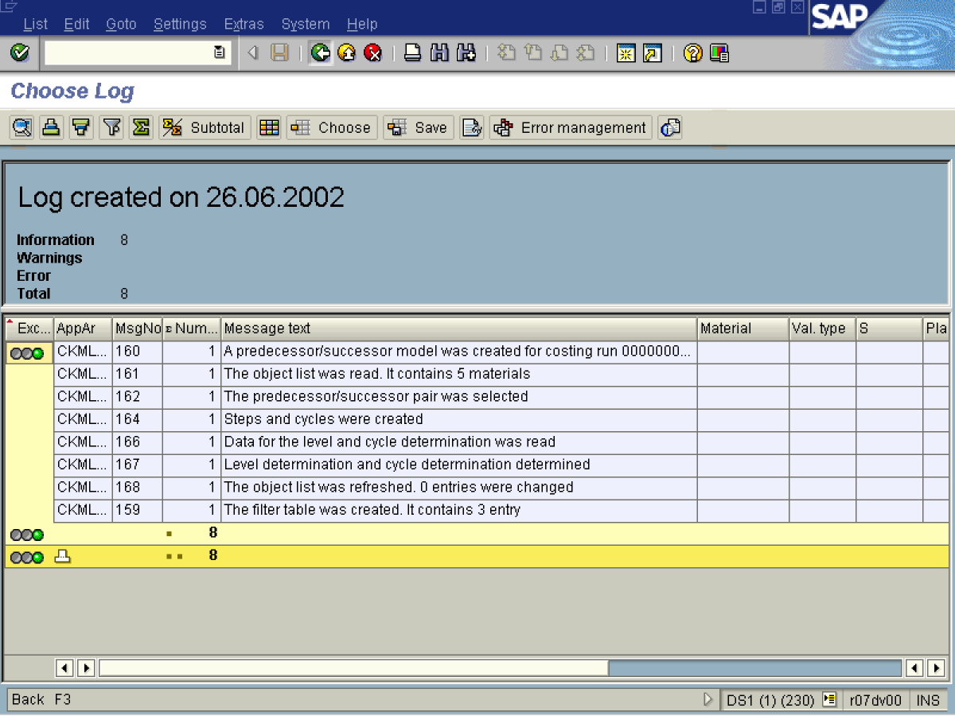
32. Click Button .
33. Click Back .

Choose Log

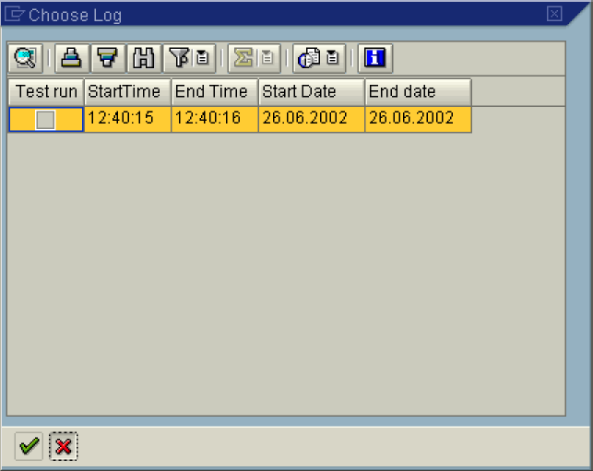

34. Click Cancel button.
Costing Cockpit: Actual Costing - Change / Execute

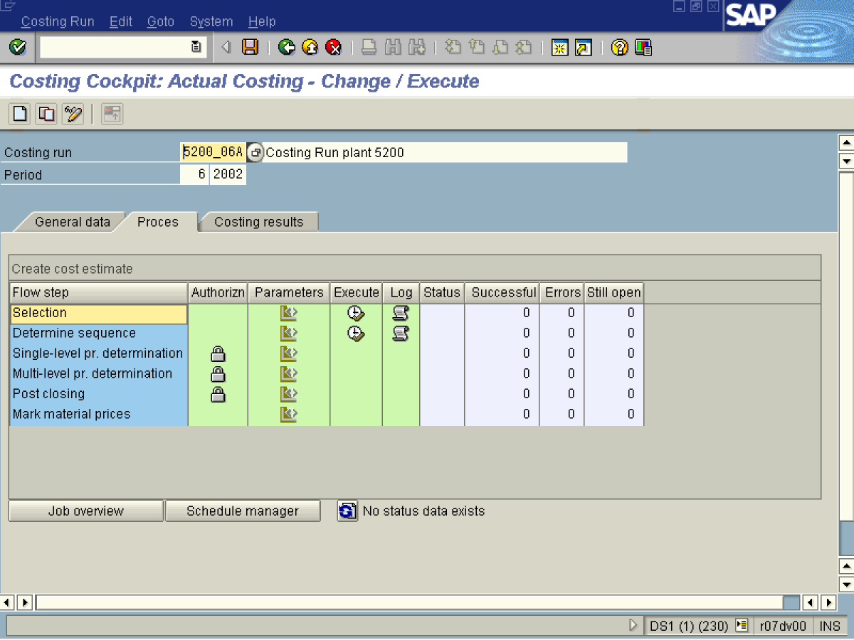

35. Click <tab button> Costing results .

Costing Cockpit: Actual Costing - Change / Execute

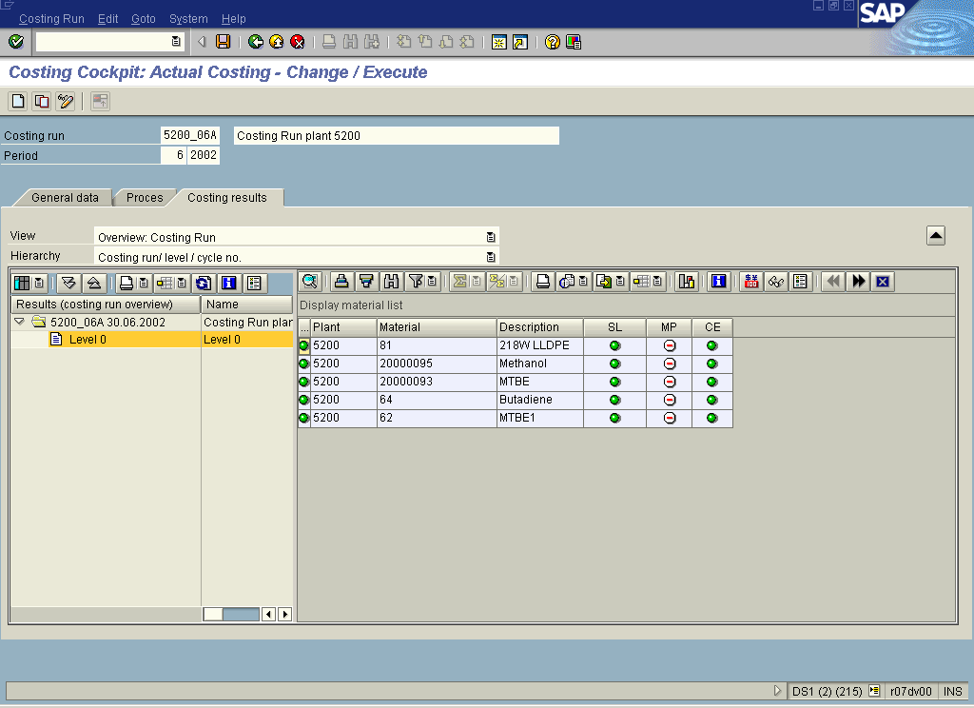

36. Select Costing run/ level / cycle no. in dropdown .
37. Select treeview node Level 0.
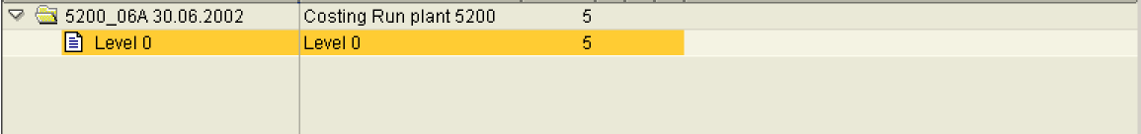

Note: In case columns are too narrow adjust a width like in Excel.

38. Click <tab button> Process .

Costing Cockpit: Actual Costing - Change / Execute

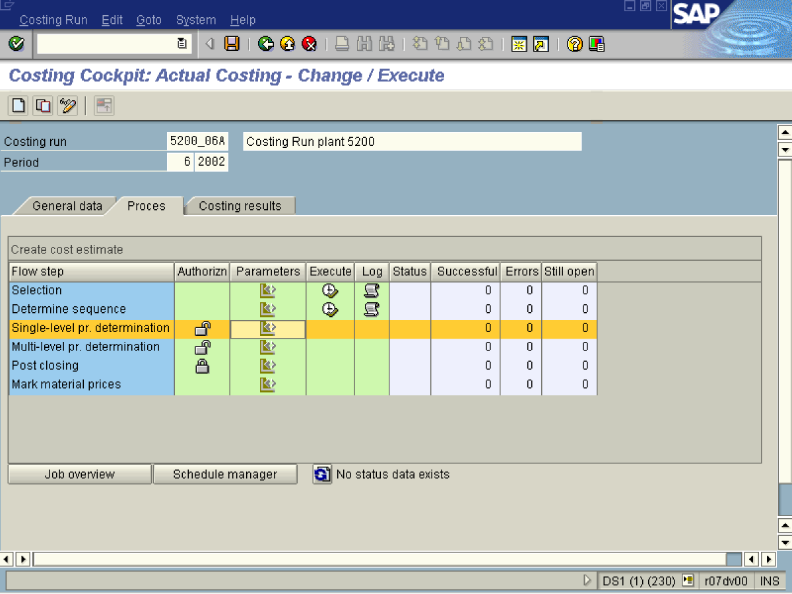

39. Click Single-level pr. determination Button .
40. Click Button .

Maintain Variant: Report SAPRCKMA_RUN_SETTLE, Variant 000000000001

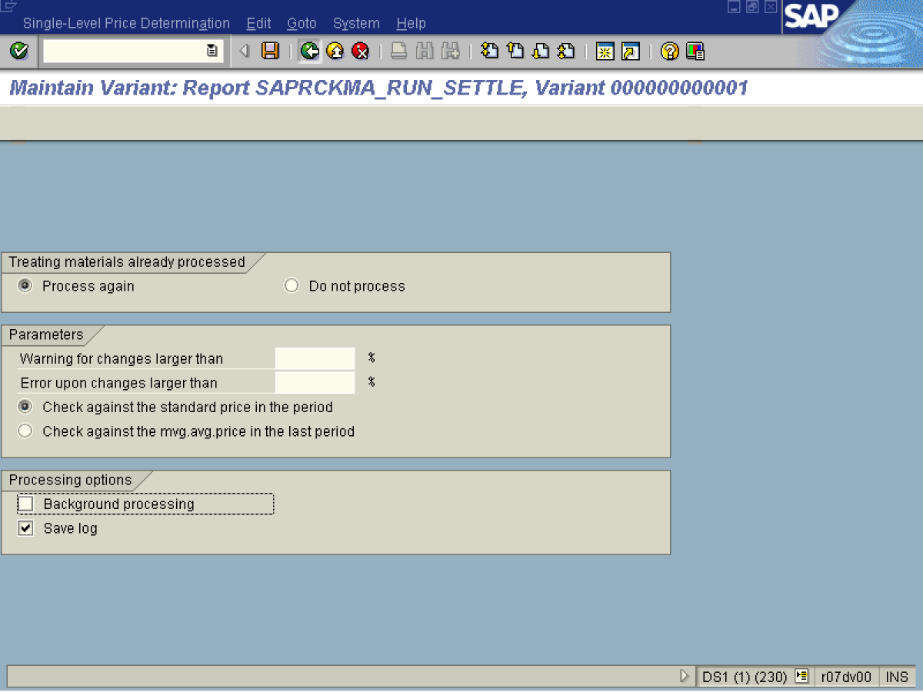
41. Click <radio button> Process again .
42. Click <radio button> Check against the standard price in the period .
43. Click <checkbox> Background processing .
44. Click Back .
45. Click Yes Button .

Costing Cockpit: Actual Costing - Change / Execute

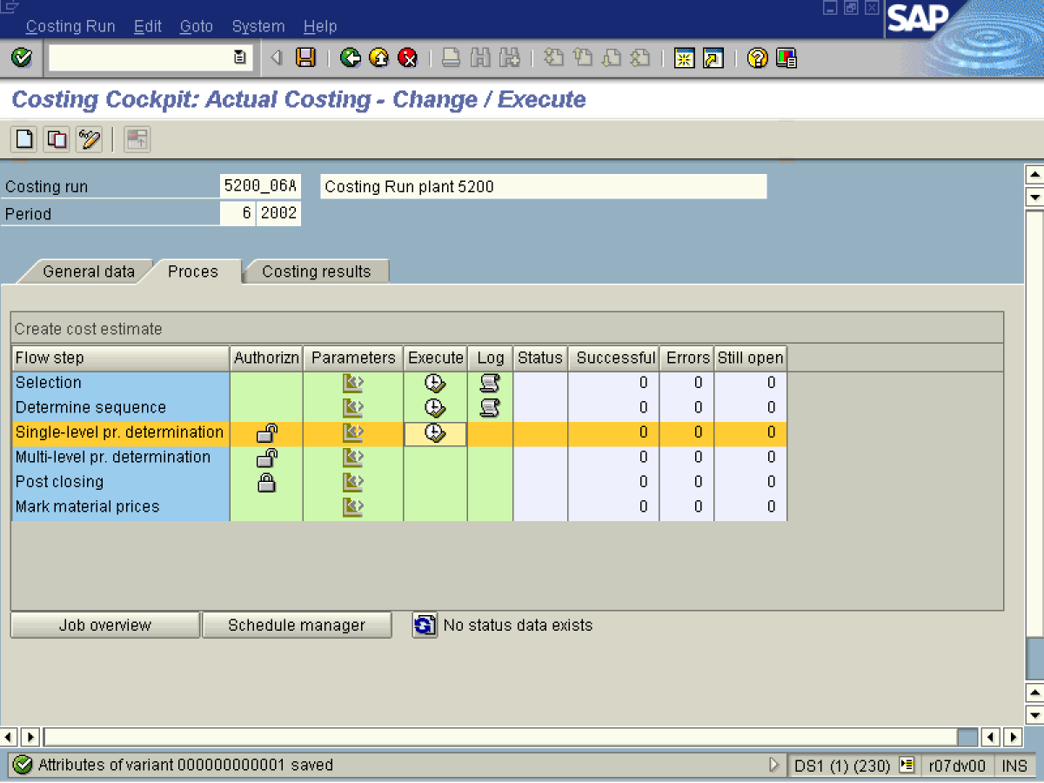

46. Click Button .

Single-Level Price Determination for Costing Run

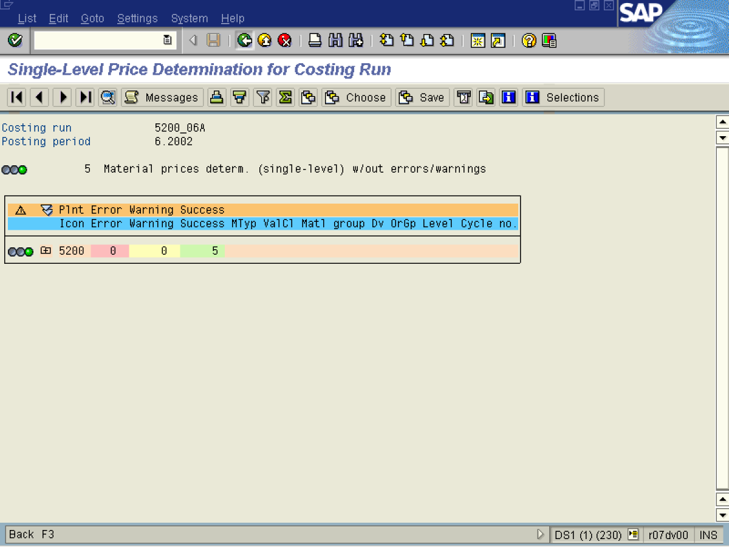
47. Click Back .
Costing Cockpit: Actual Costing - Change / Execute

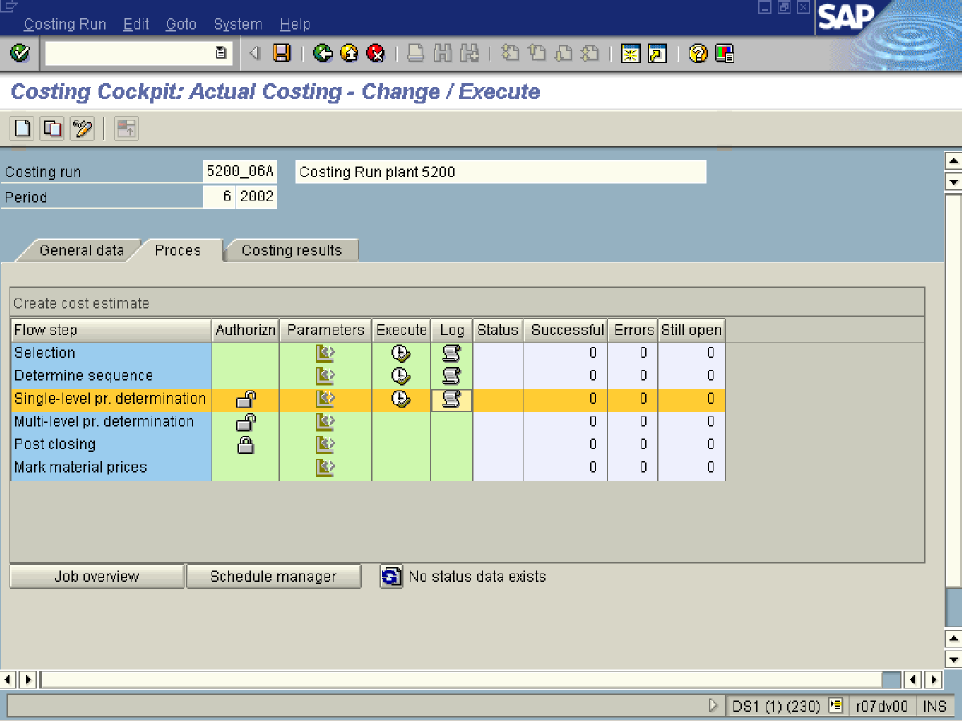
48. Click Button .

Choose Log

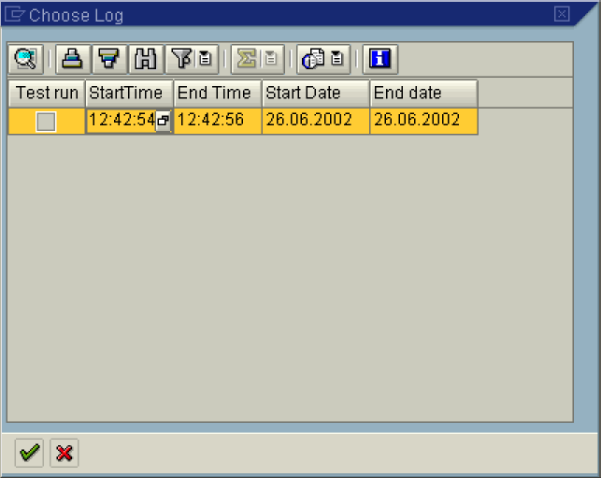

Choose Log

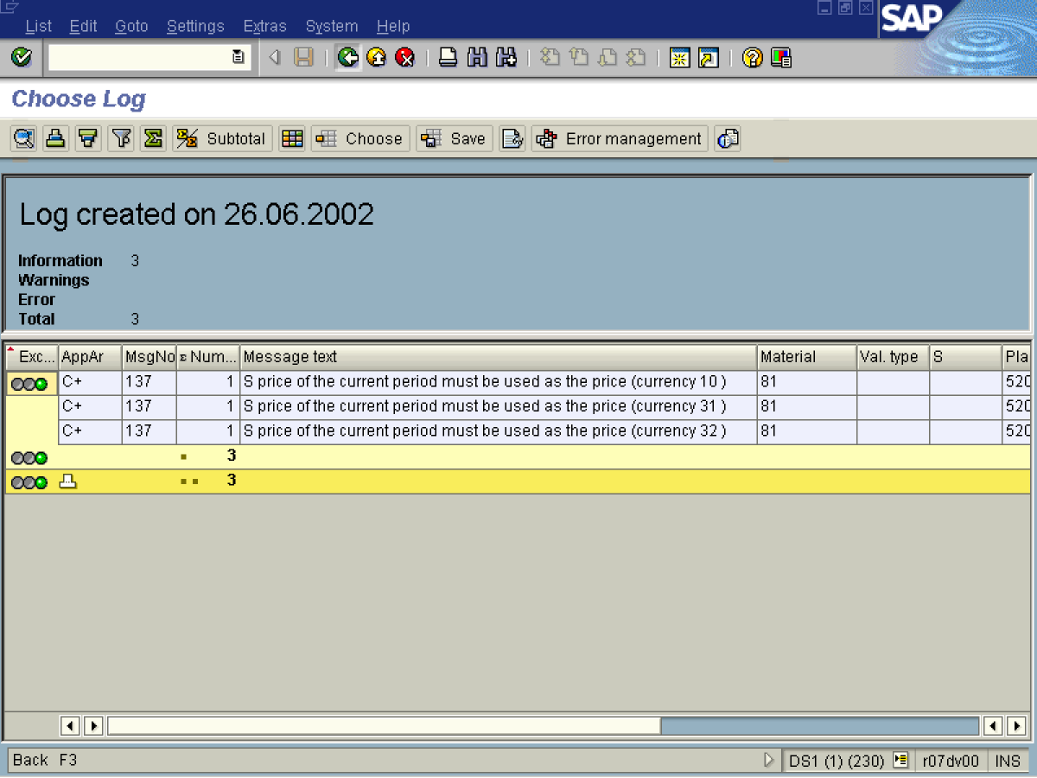
49. Click Button .

50. Click Back F3 .
Choose Log

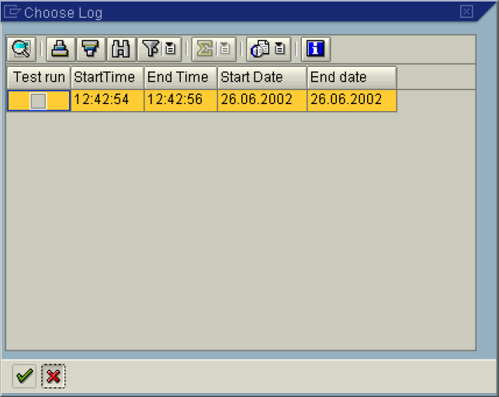

51. Click Cancel button.
Costing Cockpit: Actual Costing - Change / Execute

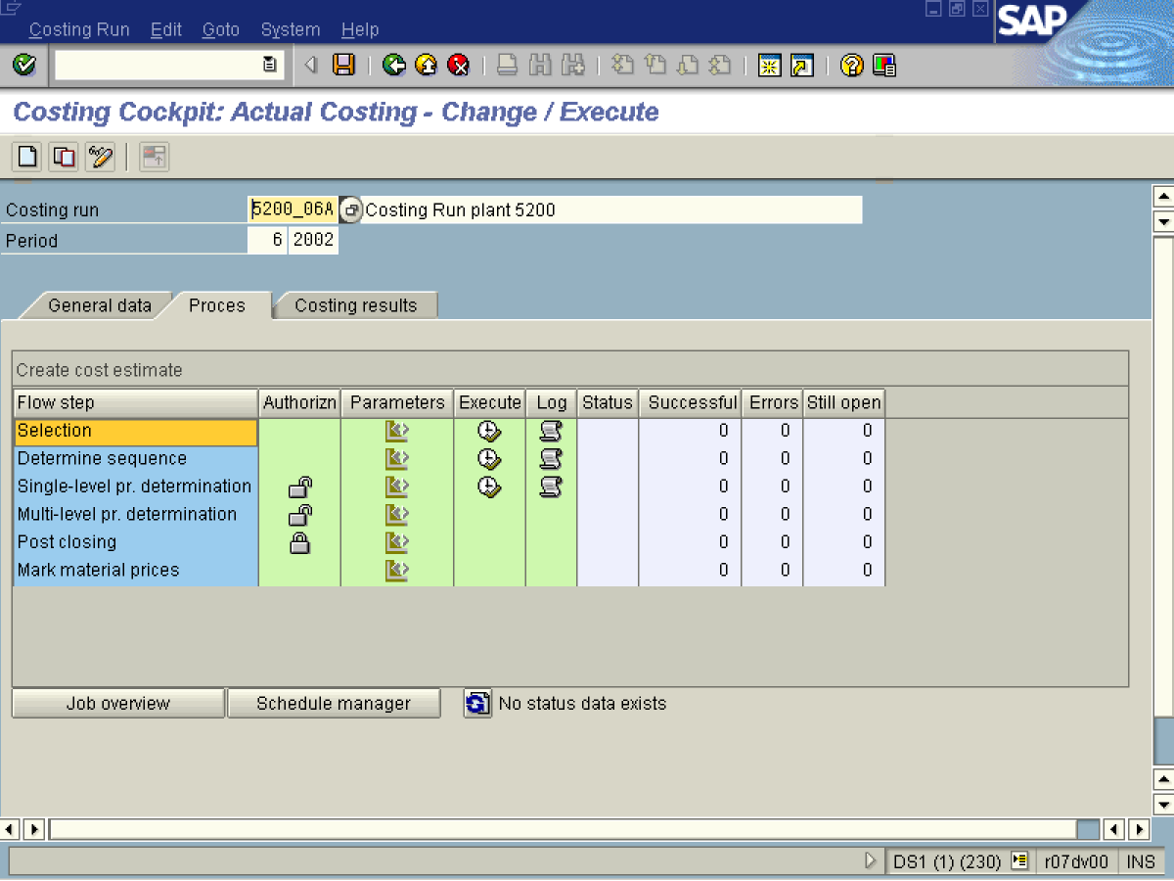

52. Click <tab button> Costing results .

53. Select CstngRun / plant / mat.type / val.class / origin group in dropdown .
54. Select Single-Level Price Determination in dropdown .
55. Select tree view node 5200.

56. Select tree view node 7900.

57. Click <tab button> Process .
Costing Cockpit: Actual Costing - Change / Execute

58. Click Button .

Maintain Variant: Report SAPRCKMLMV_RUN_MLEVEL_SETTLE, Variant 0000000

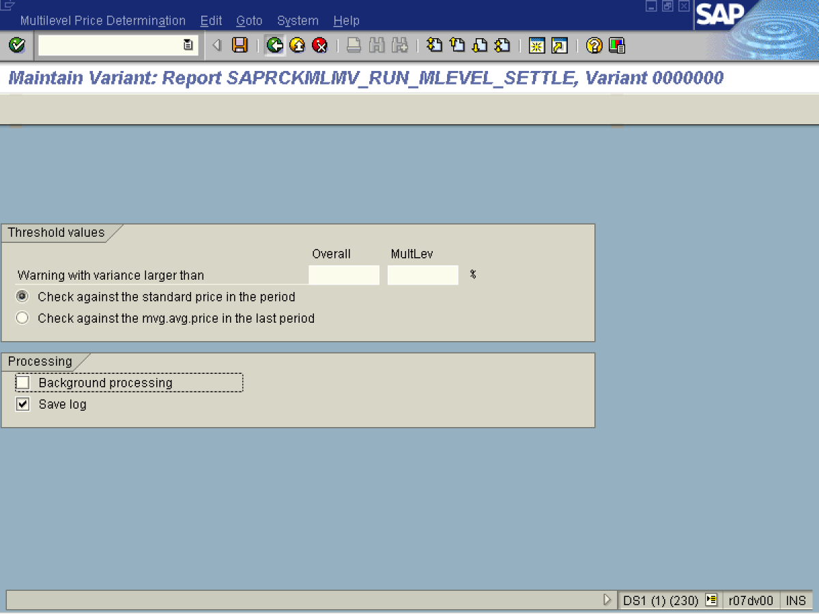
59. Click <radio button> Check against the standard price in the period .

NOTE: Option ‘Check against the moving average price in the last period’ allows us to take into consideration the last period unit price that was not released as standard price for current period. But we recommend ‘Check’ against standard price in the period – because we prefer to compare the calculated unit price to the standard price of the period.

60. Click <checkbox> Background processing .
61. Click Back .

62. Click the Yes Button.

Costing Cockpit: Actual Costing - Change / Execute

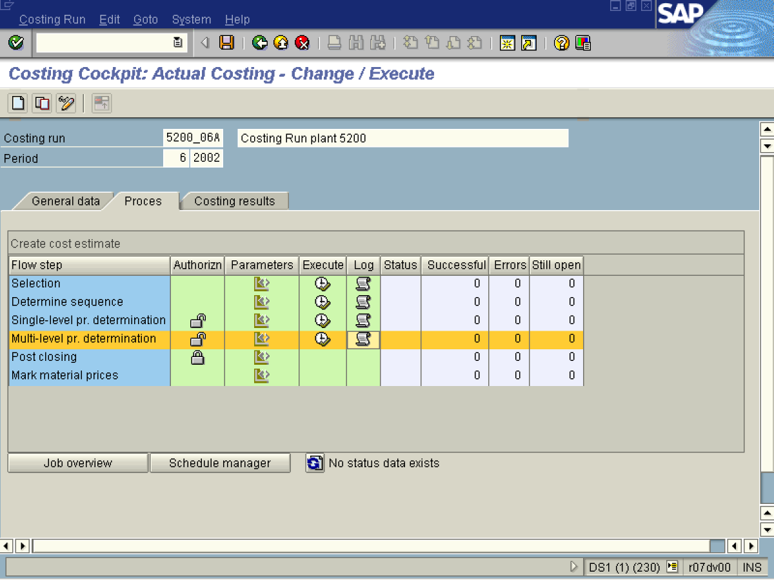
63. Click Button .
64. Click Button .

Choose Log

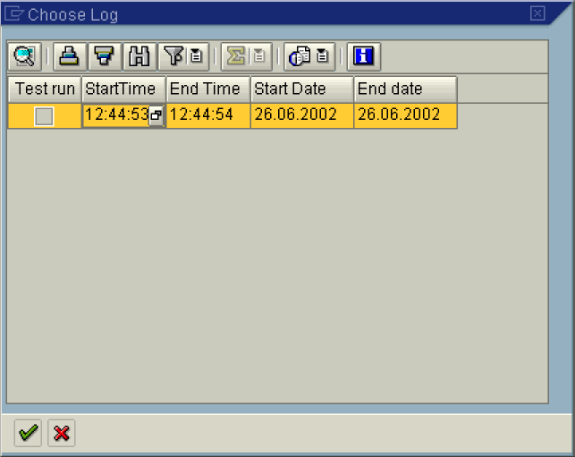

Choose Log
Note: Log is empty since we do not have any material produced in SAI (no quantity structure).

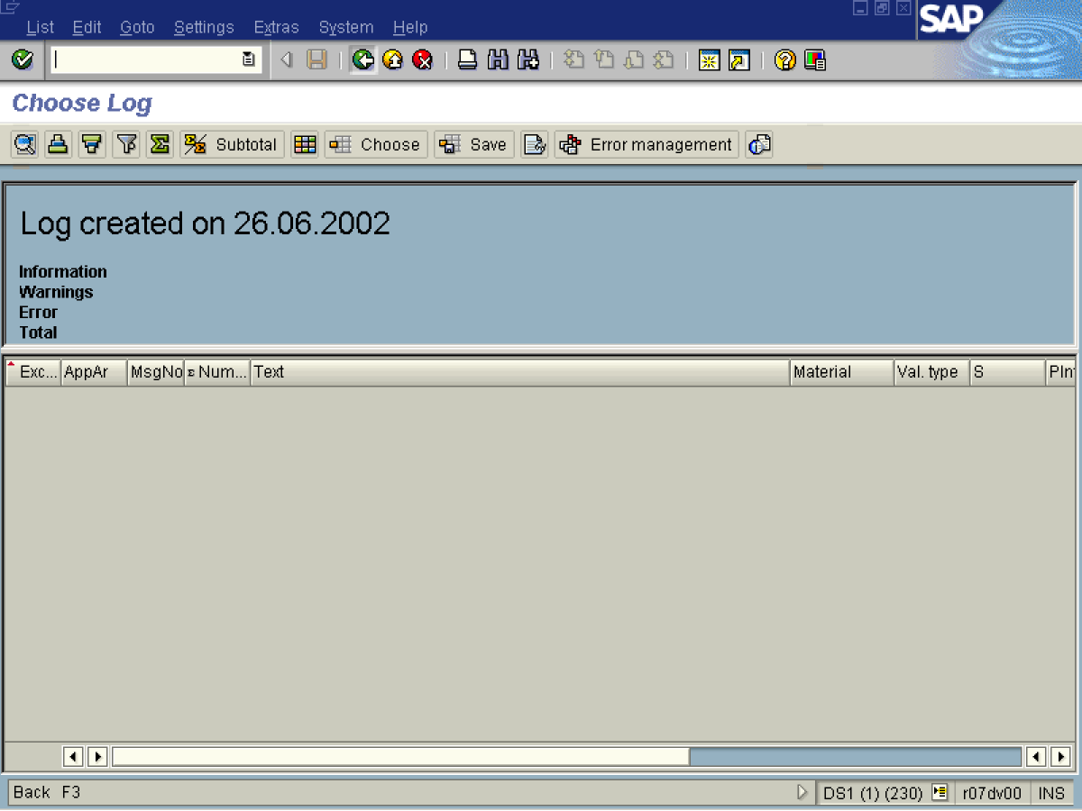
65. Click Back .

Choose Log

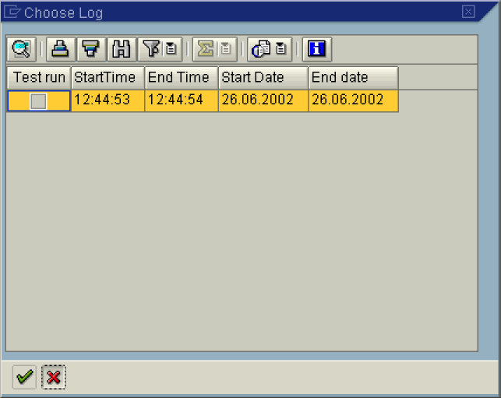
66. Click Cancel button.

Costing Cockpit: Actual Costing - Change / Execute

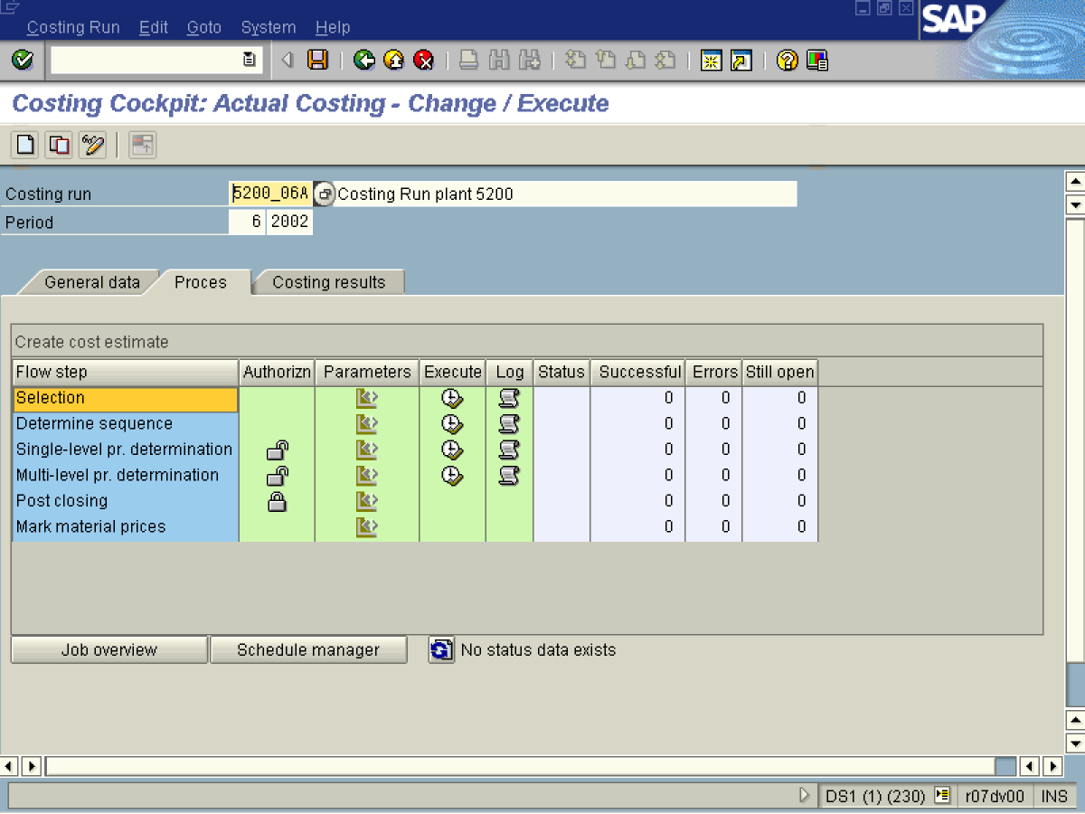
67. Click <tab button> Costing results .
68. Select Multilevel Price Determination in dropdown .
69. Click <tab button> Process .
Costing Cockpit: Actual Costing - Change / Execute

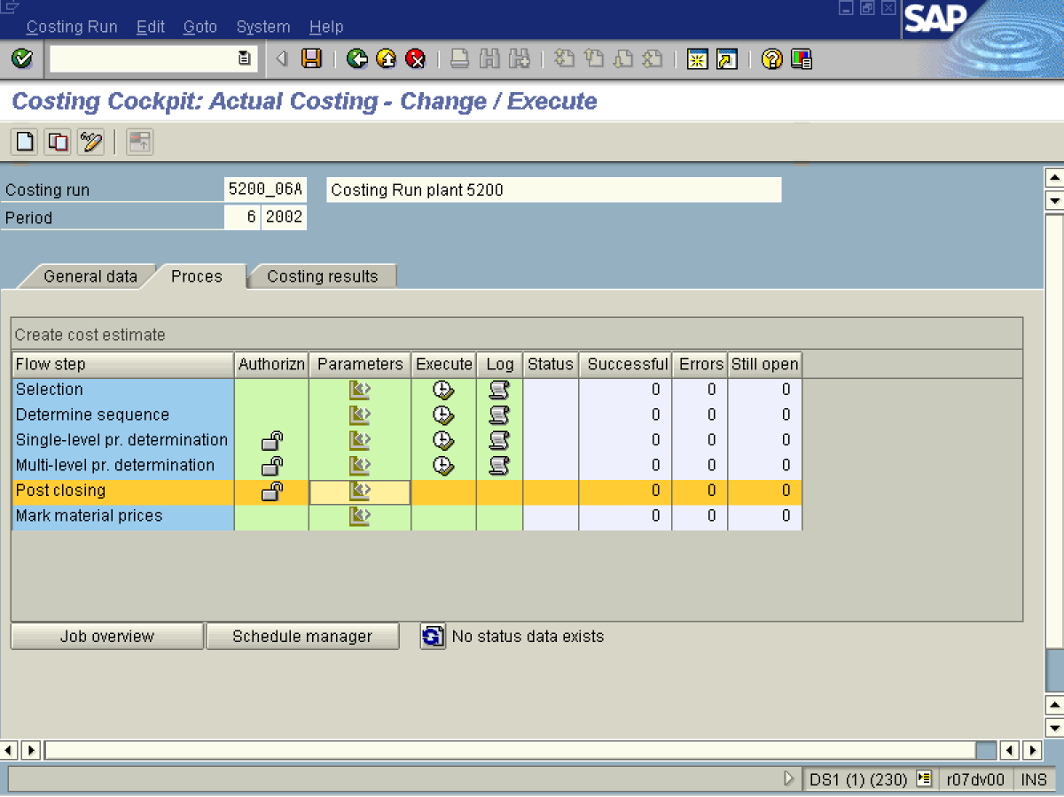

70. Click Post closing Button .
71. Click Button .

Maintain Variant: Report SAPRCKMA_RUN_CLOSE, Variant 000000000001

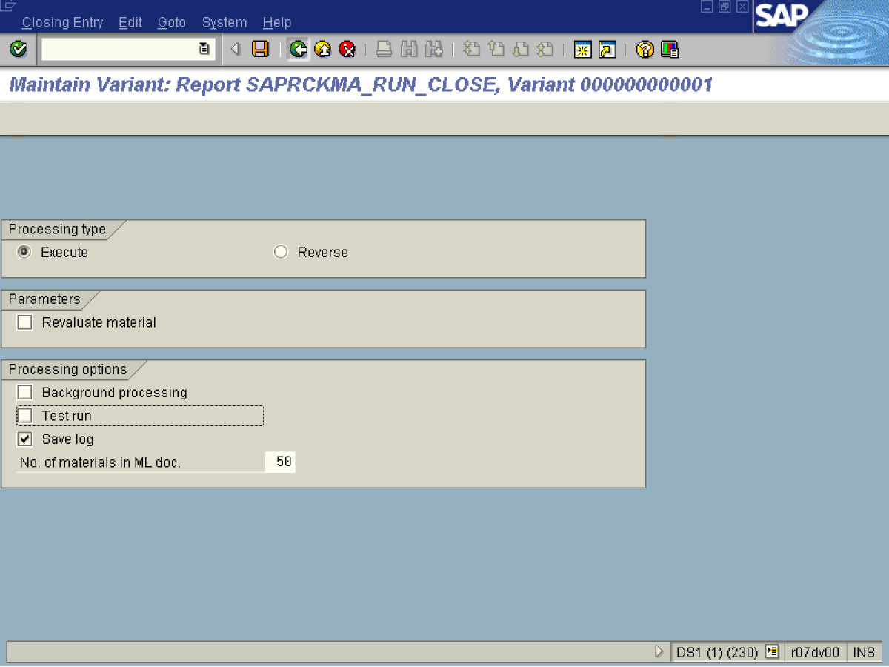
72. Click <checkbox> Background processing .

73. Click <checkbox> Test run .
As a default test mode is activated.
74. Click Back .
75. Click the Yes Button.
Costing Cockpit: Actual Costing - Change / Execute

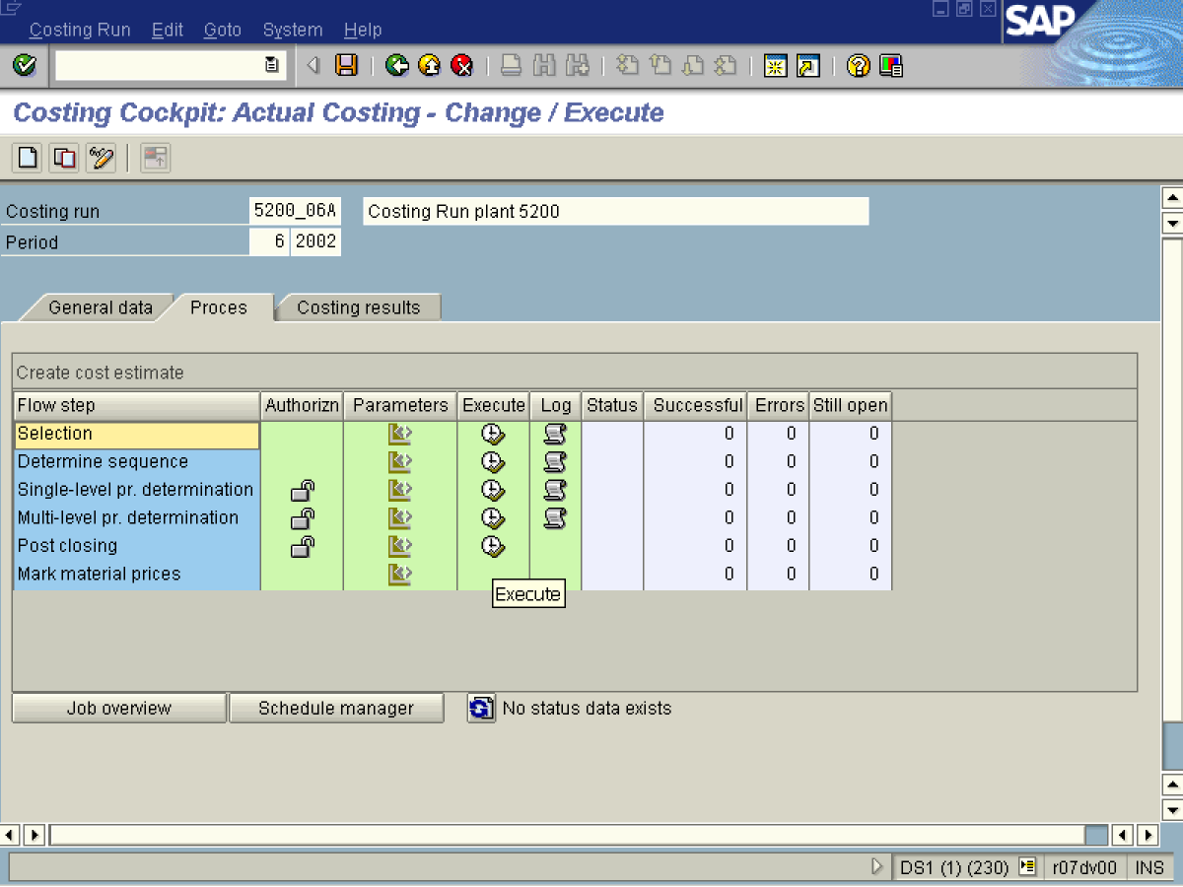

76. Click Button .

Tip: In this step you are able to proceed ‘Post closing’ only for the whole plant, to process particular materials you should use transaction CKMI.
Post closing for costing run

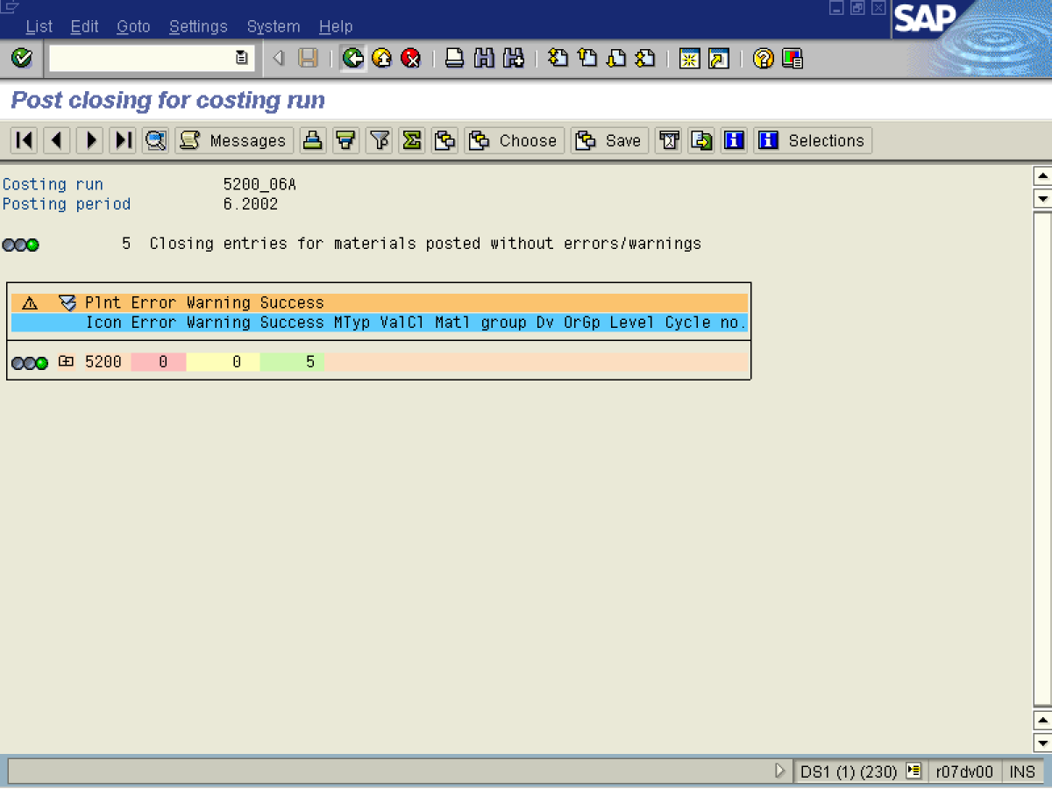

Costing Cockpit: Actual Costing - Change / Execute

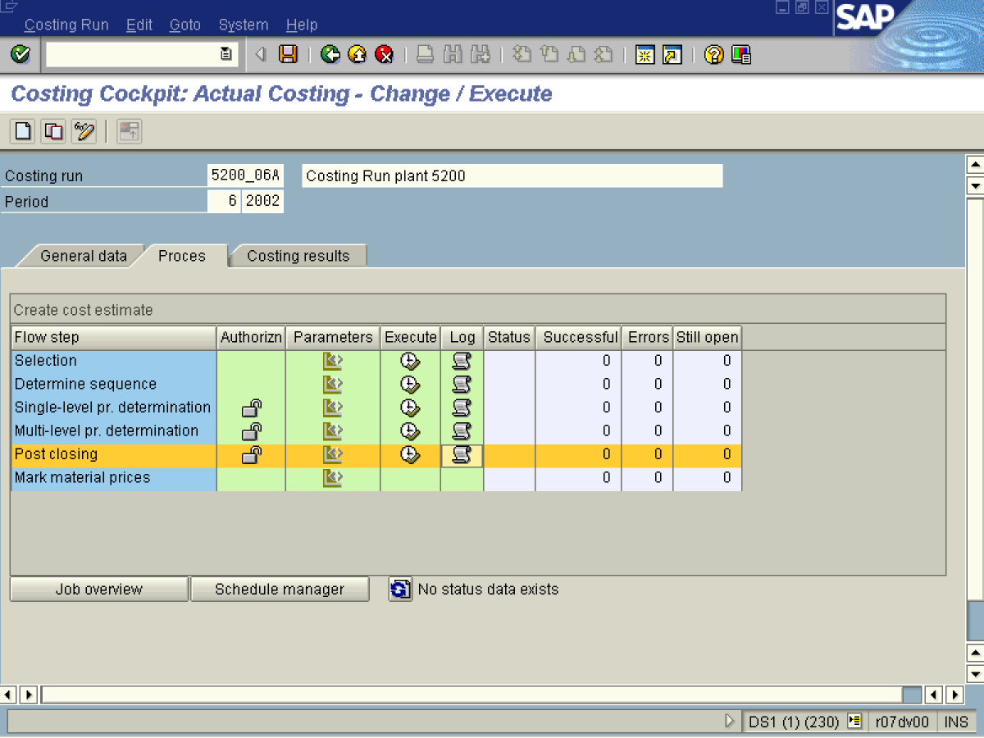

77. Click Button .

Choose Log

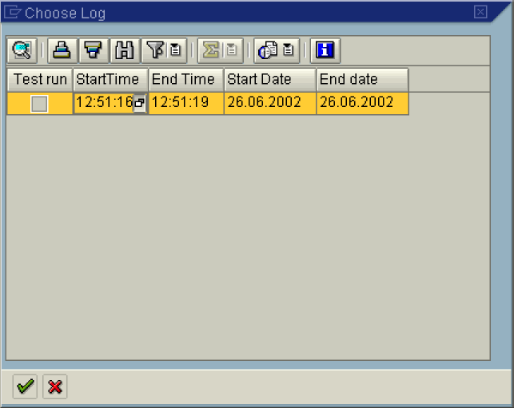

78. Press the Display button.

Choose Log

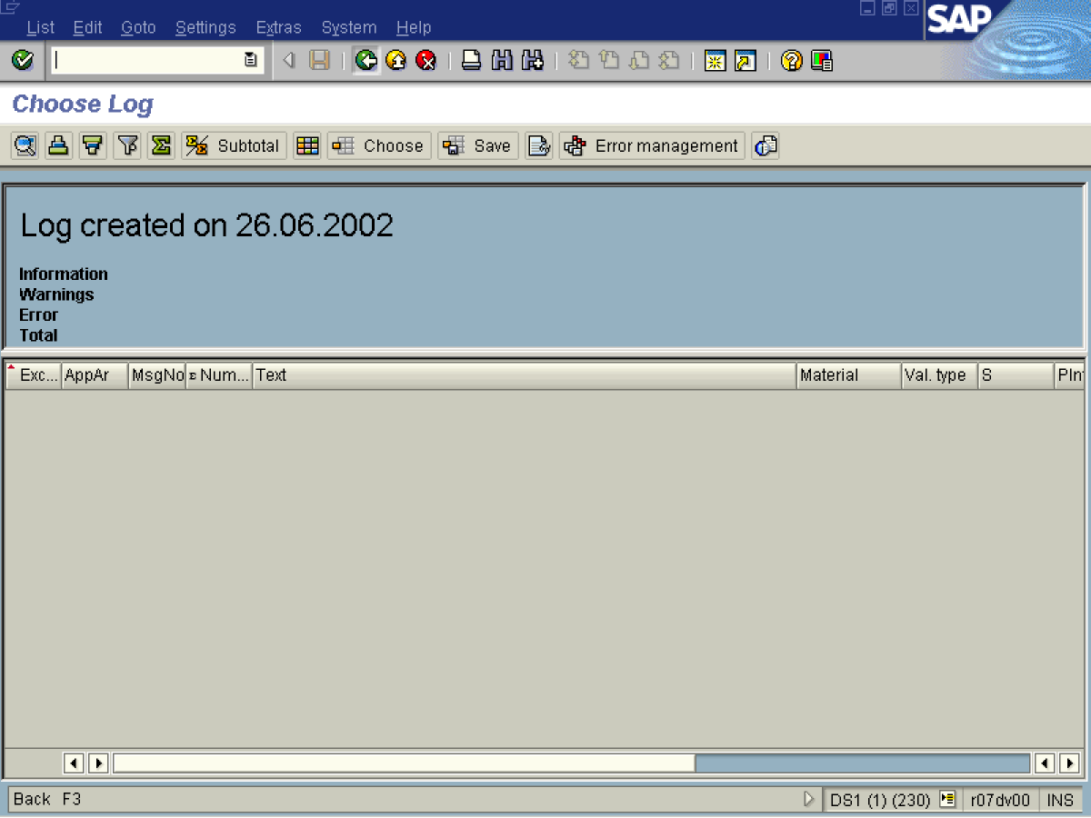

Choose Log

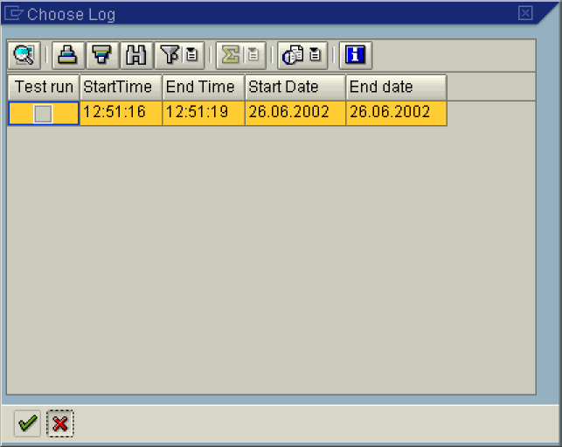

79. Click Cancel button.

80. Select tree view node 5200.
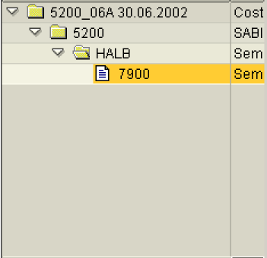
81. Click Costing results .
82. Select Closing Entry in dropdown .
Costing Cockpit: Actual Costing - Change / Execute

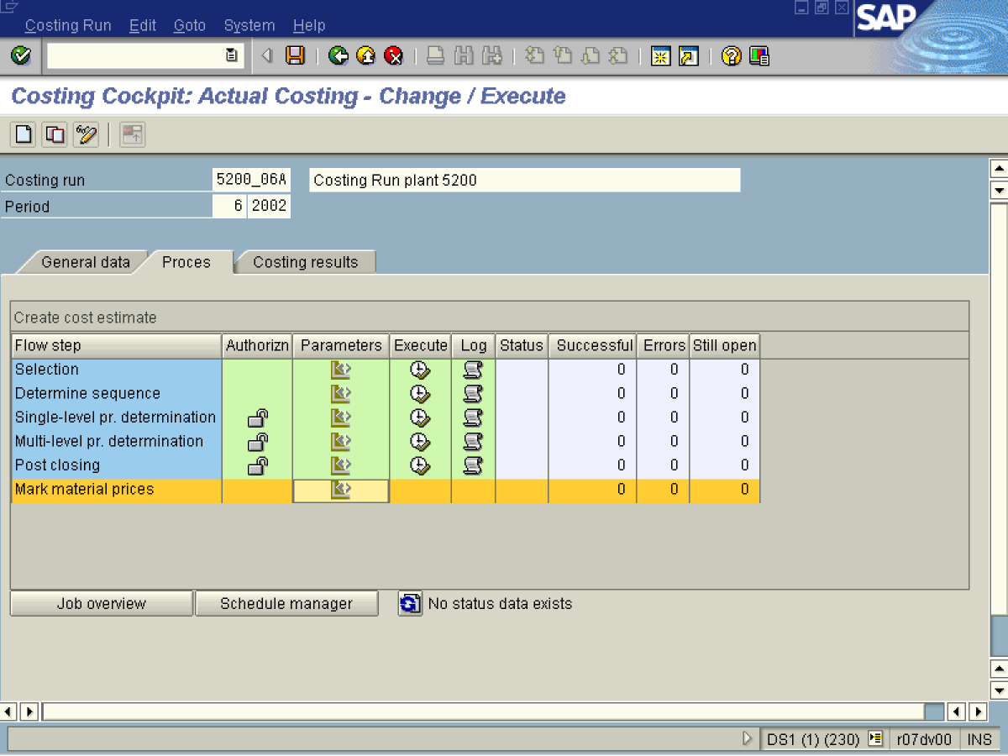

83. Click <tab button> Process .
84. Click Button .

Maintain Variant: Report SAPRCKM_PRMT_RUN_TYPE, Variant 000000000001

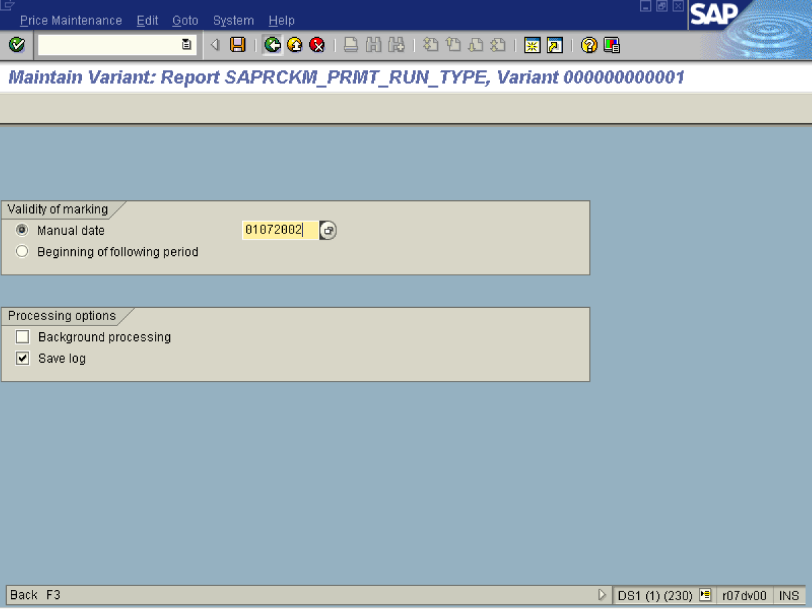
85. Update the following fields:
Field Name | Description | Values
Manual date | Enter the date from which price will be marked as a future. | Example: 01/07/2002
Button: Beginning of the following period | Switch into to choose the first day of the coming period. | Example: 01/07/2002
86. Click Back .

87. Click the Yes Button.
Costing Cockpit: Actual Costing - Change / Execute

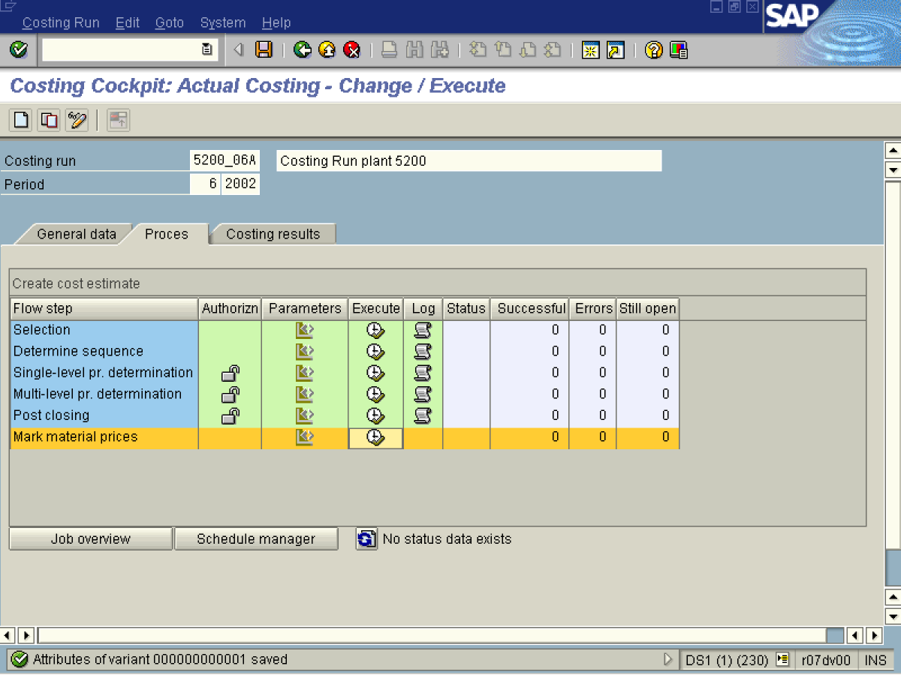

88. Click Button .

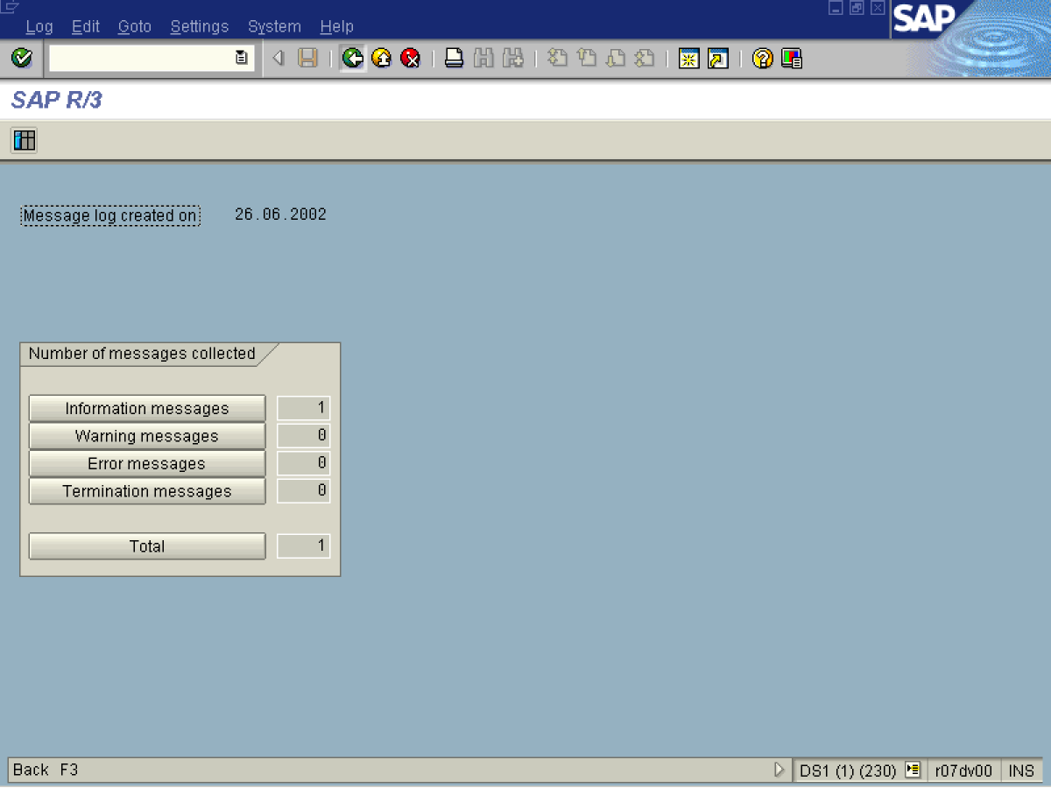
89. Click Back .

Costing Cockpit: Actual Costing - Change / Execute

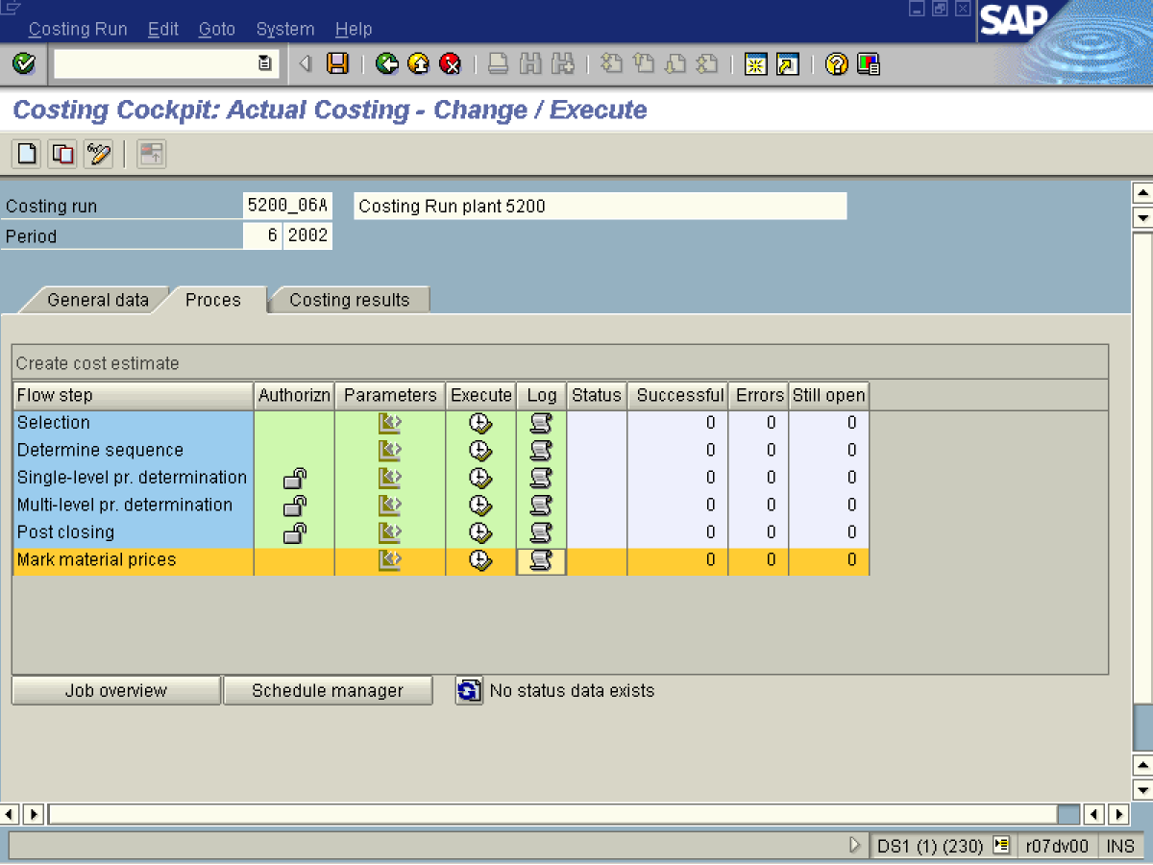
90. Click Button .

Choose Log

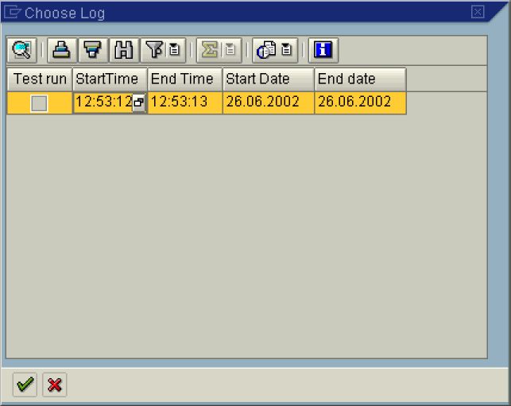

Choose Log

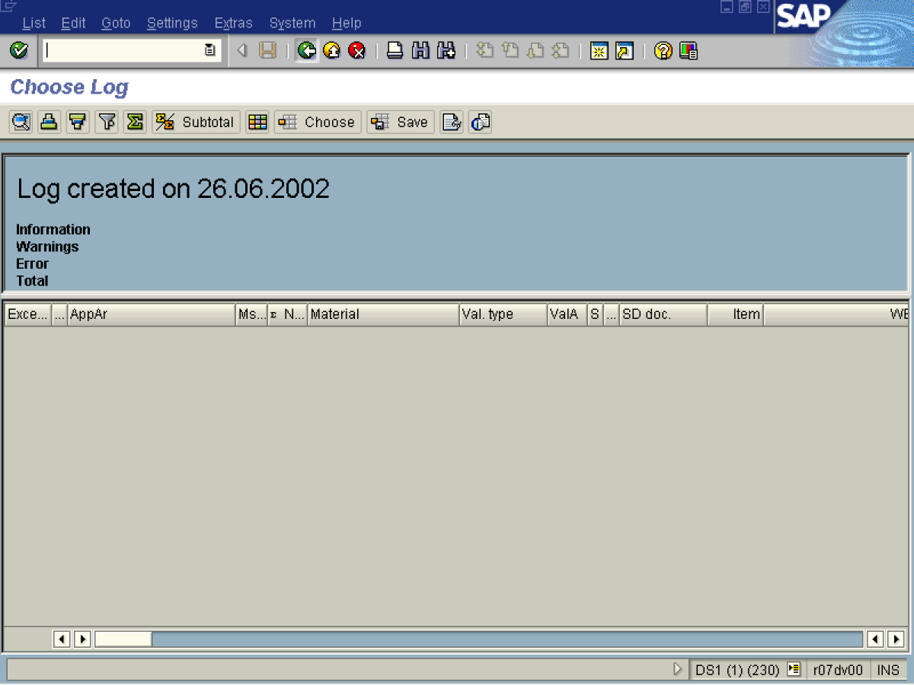
91. Click Back .

Choose Log

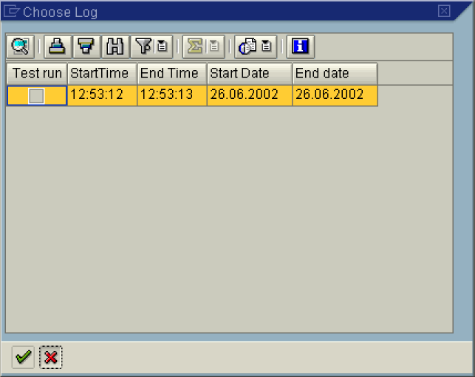
92. Click Cancel button.
93. Click <tab button> Costing results .
94. Click the Save button.

